# Stamford Chat Project Documentation

Project Title: Stamford Chatbot

Course Code: ITE222

Course Name: Programming II

Student (1) Name: Lynn Thant

Student (1) ID: 2406120001

Student (2) Name: Zwe Pyi Phyo

Student (2) ID: 2406120005

Course: ITE:222

Instructor: Dr Nay Myo Sandar

Date: 4 Jun 2025

Table of Contents

Stamford Chat Project Documentation 1

Introduction 4

Objectives 4

Tools and Technologies Used 5

System Overview 6

Class Description 7

Stamford_Chatbot.java (Main Class) 7

Stamford_Chatbot_System.java 7

Stamford_Chatbot_CourseFinder.java 8

Stamford_Chatbot_Schedule.java 9

Stamford_Chatbot_Contact.java 10

Stamford_Chatbot_CampusMap.java 11

Core Concepts Demonstrated 12

1. Loops 12

2. Constructors 12

3. Inheritance 12

4. Object Instantiation 12

5. this and Dot Operator 12

6. Java Packages 13

7. Encapsulation 13

8. Object Interaction 13

9. 2D Arrays 13

10. Static vs. Non-Static Methods 13

11. Commenting & Naming 13

12. Access Specifiers 13

Flowchart 14

Algorithm 15

Screenshots / Sample Outputs 17

Conclusion 22

References 23

# Introduction

In today’s digitally-driven educational landscape, universities are increasingly adopting chatbot technology—particularly using robust programming languages like Java to enhance student engagement, helping many students complete their respective tasks. Stamford Chatbot is a Java-based chatbot application that aims to assist students at Stamford University by providing quick and easy access to essential information that is related to campus. It is able to offer instant responses to common queries such as course information, the academic calendar, map of a campus, and the contact details of staff. This report outlines the design, functionality, and technical implementation of Stamford Chatbot.

# Objectives

The aim of this project is to develop a Java-based chat bot system that automates student support services within a university setting. The chat bot aims to provide necessary information such as course information, academic calendar, map of a campus and contact of any respective personnel in the university. The program should be easy to use as a user and consist of maintainable codes that allow smooth collaboration between developers.

# Tools and Technologies Used

|  |  |
| --- | --- |
| **Category** | **Tools / Technologies** |
| **Programming Language** | Java (JDK) – for core development and execution |
| **Development Environment** | Eclipse IDE – for writing, debugging, and managing Java code. |
| **Execution Interface** | Command Line / Terminal – for compiling and running the application |
| **Java Packages Used** | - java.util.Scanner– for reading user input  - java.lang – String manipulation.  -java.lang.Math – Date Calculation |

# System Overview

The Stamford Chatbot system is a console program built on Java that helps users with a variety of university-related questions. It offers features like searching for course information, browsing the academic calendar, navigating the campus map, and finding staff contact information. The system is modular with separate classes handling each specific task. Users interact with the chatbot through a simple text interface, entering commands like "help," "course info," or "exit" to navigate the options. The program isn’t case sensitive, allowing users to enter correct commands as they prefer.

The system follows a structured delegation pattern where user requests are processed as follows. When a user submits a command through the main class (Stamford_Chatbot), it validates the input and invokes corresponding methods on the system class (Stamford_Chatbot_System). The system class then instantiates specialized handler classes as needed. For instance, when a user requests campus map information, the main class calls the showMap() method on its Stamford_Chatbot_System instance, which in turn creates and manages a Stamford_Chatbot_CampusMap object to handle the map-specific functionality. This layered approach ensures proper separation of concerns, with each class handling specific responsibilities, the main class for input/output, the system class for request routing, and specialized classes for domain-specific operations.

The benefit of developing with this design pattern allows centralized control over a program that standardize request handling and managing error. Additionally, when adding new features, the existing work will be not be disrupted, encouraging scalability to the application. Overall, the chatbot achieves to be a clean, organized structure while maintaining flexibility for future enhancements.

# Class Description

## Stamford_Chatbot.java (Main Class)

The Stamford_Chatbot.java class serves as the entry point for the Stamford Chatbot system. It acts as a bootstrapper that initializes the application and manages user input. The class utilizes a Scanner package to read user commands and while-loop to keep the program running until the user chooses to exit. Furthermore, The class consist of main method and it creates an instance of the Stamford_Chatbot_System class, which provides access to other specialized classes. Based on the user’s input, conditional checks, if-else statements determine the appropriate action by invoking the corresponding method from the system class to handle the request.

|  |  |  |
| --- | --- | --- |
| **Method** | **Purpose** | **Example Output** |
| main(String[] args) | Entry point that initializes and runs the chatbot system | (No direct output - launches system) |
| Key Feature: Act as an entry point and instantiate system class. | | |

## Stamford_Chatbot_System.java

The Stamford_Chatbot_System.java function as a central control class. The class consists of a constructor that display a welcoming message and several methods that invoke an instance of a specialized tasks.

|  |  |  |
| --- | --- | --- |
| **Method** | **Purpose** | **Example Output** |
| Constructor | Initializes the chatbot system and displays welcome message | "STAMFORD CHATBOT” Type 'help' for options" |
| Help() | Displays the main help menu | "1. Course Info  2. Academic Calendar  3. Campus Map  4. Contact Staff  5. Exit" |
| findCourse() | Launches course information module | "What area are you interested in?  - Computing  - Art  - Business" |
| showSchedule() | Starts the academic calendar system | "Enter the year (2025 or 2026) to view the academic calendar…" |
| showMap() | Initiates campus location services | “Where? (Library/Gym/Cafeteria):” |
| contactStaff() | Provides department contact information | "Department: (Admissions/IT/Finance):" |
| **Key Feature**: Act as a central command between main class and module classes | | |

## Stamford_Chatbot_CourseFinder.java

The Stamford_Chatbot_CourseFinder.java class is a specialized class designed to provide detailed course information based on user queries. It interacts with users through a structured menu system, guiding them to select an academic area and then a specific subject within that area. Its findCourse() is a main method that orchestrate the user inteaction and logic behind the course lookup. Lastly, its modular design ensures clean separation from other chatbot functionalities, promoting maintainability and scalability.

|  |  |  |
| --- | --- | --- |
| **Method** | **Purpose** | **Example Output** |
| findCourse() | Interacts with the user via console to suggest relevant courses based on input area and subject | User enters “Computing” → then “network” → gets info about ITE 554: Computer Networks. |
| **Key Feature**: The Stamford_Chatbot_CourseFinder class interactively guides users to discover course information based on their area of interest and subject preferences in Computing, Art, or Business. | | |

## 

## Stamford_Chatbot_Schedule.java

The Stamford_Chatbot_Schedule class is one of core component of the Stamford Chatbot system, designed to display academic calendars and key dates for specified years (2025 or 2026). It generates a monthly calendar view with annotations for important events and supports user interaction through a console interface. The class consists of constructor and several methods that allow users to select year, view a formatted calendar, check important dates and get detailed event summaries. It is built with a 6x7 2D array to represent weeks and days.

|  |  |  |
| --- | --- | --- |
| **Method** | **Purpose** | **Example Output** |
| Constructor | Starts user input loop to display the calendar for year 2025 or 2026. | "Enter the year (2025 or 2026) to view the academic calendar (or 0 to exit):" |
| displayCalendar(int year) | Displays the full 12-month calendar for the given year, marking holidays and exam dates. | Calendar grid with symbols (e.g., 15X, 01*) + summary at the end. |
| resetCalendarGrid() | Resets the 2D calendar array before rendering each month's calendar. | Internal operation; clears the grid. No direct output. |
| printEventSummary(int year) | Prints a summary of holidays and fake exam dates for the selected year. | Shows: 2025-01-01 - New Year's Day (Holiday), etc. |
| isLeapYear(int year) | Checks whether a given year is a leap year. | isLeapYear(2024) → true, isLeapYear(2025) → false |
| getDaysInMonth(int year, int month) | Returns the number of days in a specific month of a year. | getDaysInMonth(2025, 2) → 28, getDaysInMonth(2024, 2) → 29 |
| getMonthName(int month) | Converts a numeric month to its full name. | getMonthName(3) → "March" |
| getDayOfWeek(int year, int month, int day) | Calculates day of the week (0 = Sunday, ..., 6 = Saturday). | getDayOfWeek(2025, 1, 1) → 3 (Wednesday) |
| isFakeHoliday(int year, int month, int day) | Determines if a given date is marked as a fake holiday. | isFakeHoliday(2025, 2, 12) → true (Fake Winter Break) |
| isFakeExamDate(int year, int month, int day) | Determines if a given date falls in a fake exam period. | isFakeExamDate(2025, 5, 18) → true (Midterm) |
| Key features: The Stamford_Chatbot_Schedule class dynamically generates and displays a year-long academic calendar for 2025 or 2026, highlighting holidays and exam periods within a formatted monthly grid. | | |

## Stamford_Chatbot_Contact.java

The Stamford_Chatbot_Contact class is a specialized module within the Stamford Chatbot system that handles contact information requests for university departments. It provides users with email addresses and phone numbers for key departments such as Admissions, IT and Finance departments through an interactive console menu.

|  |  |  |
| --- | --- | --- |
| **Method** | **Purpose** | **Example Output** |
| Constructor Stamford_Chatbot_Contact() | Initializes the contact system and prompts the user for a department choice. | "Department: (Admissions/IT/Finance) : " |
| displayAdmissions() | Shows Admissions contact info. | “✉️ admission@stamford.edu  📞 02-765-4321 (9AM-5PM)” |
| displayIT() | Shows IT Helpdesk contact info. | “✉️ it-support@stamford.edu  📞 02-123-4567 (9AM-5PM)” |
| displayFinance() | Shows Finance Office contact info. | “✉️ cashier_rm9@stamford.edu  📞 02-769-4000 (8:30AM-5:30PM)” |
| Key Feature: The Stamford_Chatbot_Contact class allows users to quickly retrieve contact information for specific university departments such as Admissions, IT, and Finance. | | |

## Stamford_Chatbot_CampusMap.java

The Stamford_Chatbot_CampusMap class is also one of the specialized module within the Stamford Chatbot system that provides location-based information about key campus facilities. It offers users quick access to details such as building locations, operating hours, and amenities for predefined campus spots.

|  |  |  |
| --- | --- | --- |
| **Method** | **Purpose** | **Example Output** |
| Constructor Stamford_Chatbot_CampusMap() | Initializes the campus map system and prompts the user for a location choice. | "Where? (Library/Gym/Cafeteria): " |
| displayLibrary() | Shows Library location and hours. | “Building A, 1st Floor  Open 7AM – 7PM” |
| displayGym() | Informs users about gym availability (currently not at Rama 9 campus). | “Sorry, Not Available in Rama 9 Campus” |
| displayCafeteria() | Displays Cafeteria details, including today’s menu. | "Building B, 1st Floor  Open 7AM-7PM  Today's Menu: Pad Thai, Salad" |
| Key Feature: The Stamford_Chatbot_CampusMap class provides users with location and availability details for key campus facilities such as the library, gym, and cafeteria based on their input. | | |

# Core Concepts Demonstrated

## 1. Loops

**while loop**: Used in Stamford_Chatbot.java to keep the program running until the user exits.

**for loop**: In Stamford_Chatbot_Schedule.java to iterate through months/days for calendar generation.

**if/else if**: For menu navigation (e.g., checking user input for "course info" or "calendar").

**nested if**: In Stamford_Chatbot_CourseFinder.java to handle hierarchical selections (area → subject).

## 2. Constructors

**Constructors**: Each classes initializes its own state.

**Method Overloading**: Not explicitly used.

## 3. Inheritance

Not Applied: The project uses composition instead of inheritance.

## 4. Object Instantiation

## 

## 5. this and Dot Operator

**This**: not heavily used.

**Dot Operator**: Frequently used to access methods (eg. chatBot.findCourse()).

## 6. Java Packages

**Java.util.Scanner**: For user input in all interactive classes.

**Java.lang.Math**: Used in Stamford_Chatbot_Schedule for date calculations.

## 7. Encapsulation

**Private Fields**: Limited (most classes rely on methods, not fields).

**Getters/Setters**: Not explicitly needed (data is processed via methods).

## 8. Object Interaction

**Collaboration:** Stamford_Chatbot_System.java coordinates interactions between the main class and specalized classes (e.g., CourseFinder.java, CampusMap.java).

## 9. 2D Arrays

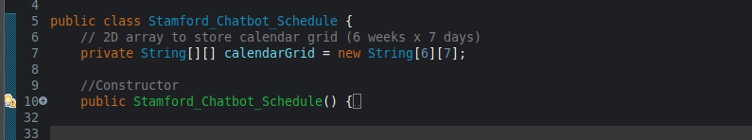**6x7**: 6x7 2D Array is implemented in Calendar Logic to present weeks and days.

## 10. Static vs. Non-Static Methods

**Static**: Helper methods like getDayOfWeek() in Stamford_Chatbot_Schedule.

**Non-Static**: Most methods (e.g., findCourse(), displayLibrary()) are instance-based.

## 11. Commenting & Naming

**Comments**: Minimal but descriptive (e.g., // Checks if a date is a fake holiday).

**Naming**: Follows conventions (e.g., displayCafeteria(), isFakeExamDate).

## 12. Access Specifiers

**public**: Methods called across classes (e.g., showSchedule()).

**private**: Rare (project focuses on method-based encapsulation).

# Flowchart

Insert the flowchart for the whole project, including the classes.

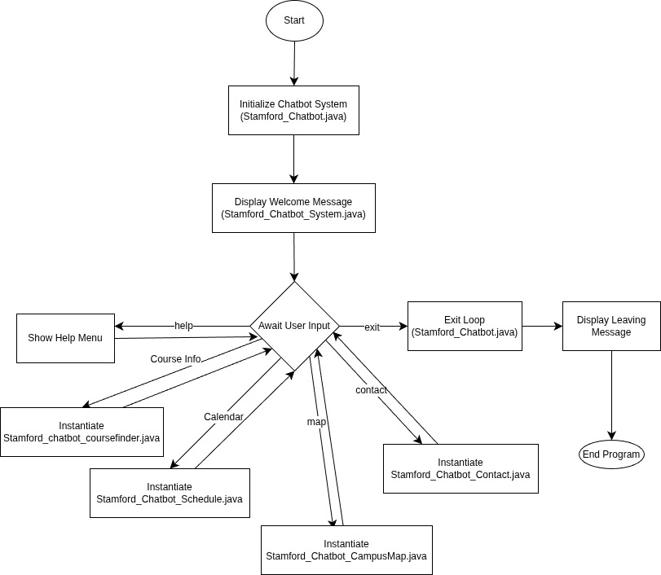

# Algorithm

Step 1: Start

Step 2: Create an instance of Stamford_Chatbot_System

Step 3: Display Welcome Message.

Step 4: Prompt user for input

Step 5: Read the input using Scanner.

Step 6: Check input against commands (help, course info, academic calendar, campus map, contact staff and exit).

Step 6.1: If user enter course info.

Step 6.1.1: Prompt user to select an area of study.

Step 6.1.2: Read user’s area choice.

Step 6.1.2: Prompt for a subject keyword.

Step 6.1.3: If Match, display course details.

Step 6.1.4 Return to main loop (Step 4)

Step 6.2: If user enter academic calendar

Step 6.2.1: Prompt user for a year

Step 6.2.2: If year is valid, print calendar grind.

Step 6.2.3: Else if year = 0, return to the main loop (Step 4)

Step 6.2.4: Else print “Invalid Year”

Step 6.3: If user enter campus map

Step 6.3.1: Prompt user for location (Library, Gym, Cafeteria).

Step 6.3.2: If valid location, display appropriate result.

Step 6.3.3: Return to main loop (Step 4)

Step 6.4: If user enter contact staff

Step 6.4.1: Prompt user for department

Step 6.4.2: Check department, if correct → display appropriate result.

Step 6.4.3: Return to main loop (Step 4)

Step 7: Repeat from Step 4 until “exit” is entered.

Step 8: Break While Loop

Step 9: Close Scanner.

Step 10: Display “Bye! See you again”

# Screenshots / Sample Outputs

Insert screenshots or sample output from your program execution here.

1. Start

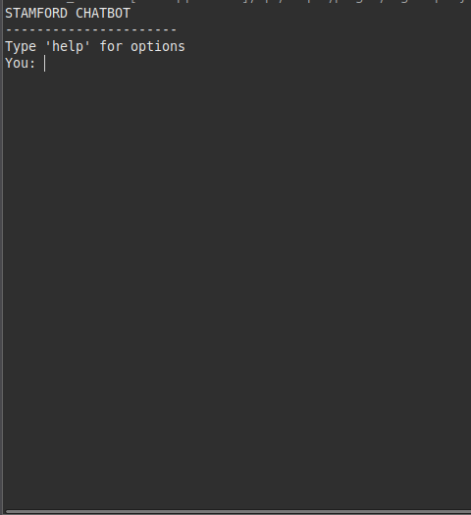

2. User enter ‘help’

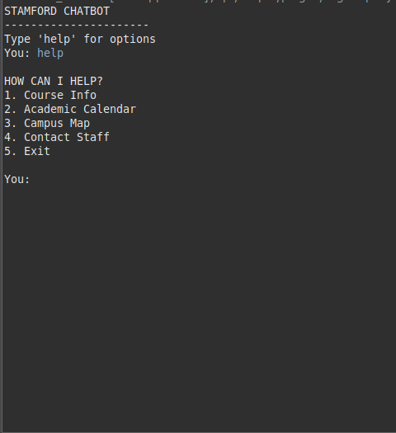

3. User enter ‘course info’.

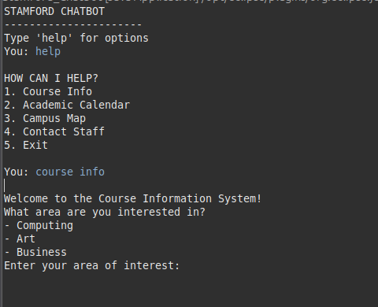

3.1 User chose ‘computing’ as an area of interest.

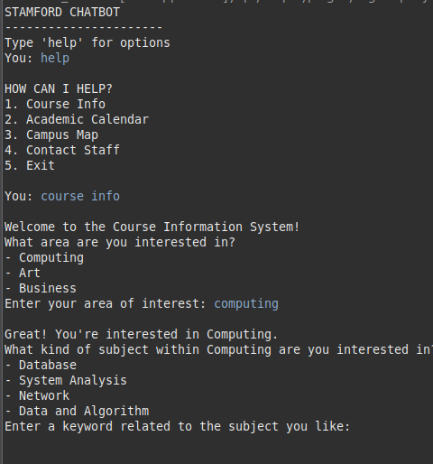

3.2 User chose ‘Database’ as a subject.

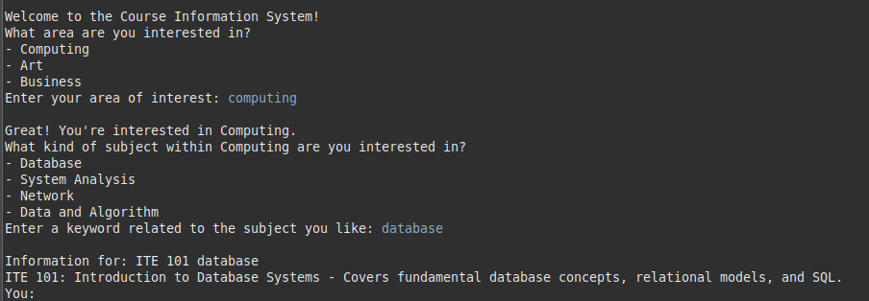

4. User enter ‘Academic Calendar’.



4.1 User enter year ‘2025’.

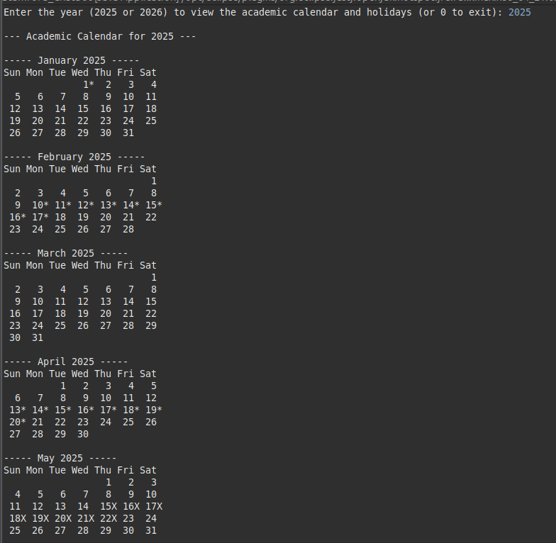

# 

4.2 User enter ‘exit’ to get back to menu.

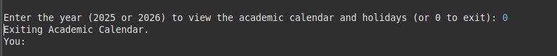

5. User enter ‘Campus Map’.

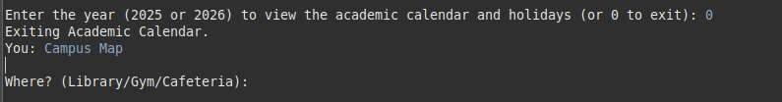

5.1 User finds about ‘Library’.

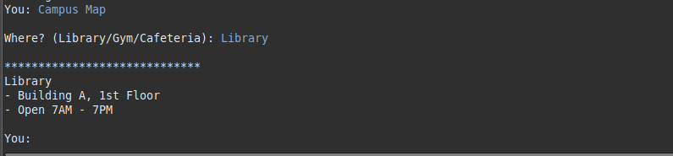

6. User enter about ‘Contact Staff’.

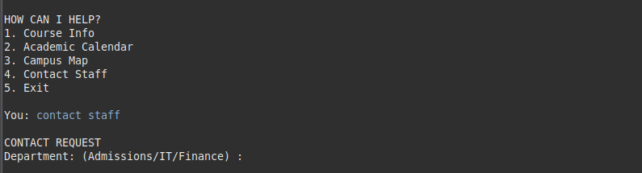

6.1 User finds about ‘IT Department’.

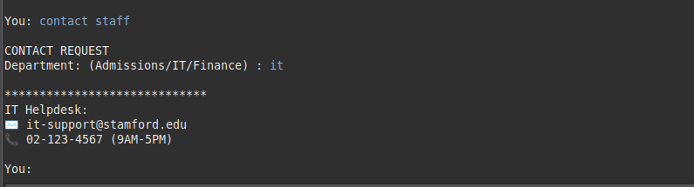

7. User Exit the Program

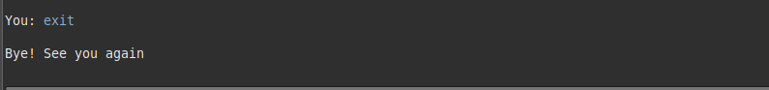

# Conclusion

Summarize your experience and what you learned through this project.

# References

List any resources or references you used during the development.